# Lab: Arrays

Problems for in-class lab for the [“Technology Fundamentals” course @ SoftUni](https://softuni.bg/trainings/2056/technology-fundamental-september-2018#lesson-9619).   
Submit your solutions in the SoftUni judge system at: [Arrays-Lab](https://judge.softuni.bg/Contests/1243/Arrays-Lab)

## Sum First and Last Array Elements

Write a function that receives an array of strings and prints the sum of first and last element in that array

### Examples

|  |  |
| --- | --- |
| **Input** | **Output** |
| ['20', '30', '40'] | 60 |
| ['10', '17', '22', '33'] | 43 |
| ['11', '58', '69'] | 80 |

### Hints

Use the Number function.

## Day of Week

Write a program which receives a **number** and prints the corresponding name of the day of week. If the number is not a valid day, print '**Invalid day!**'

### Examples

|  |  |
| --- | --- |
| **Input** | **Output** |
| 3 | Wednesday |
| 6 | Saturday |
| 11 | Invalid day! |

### Hints

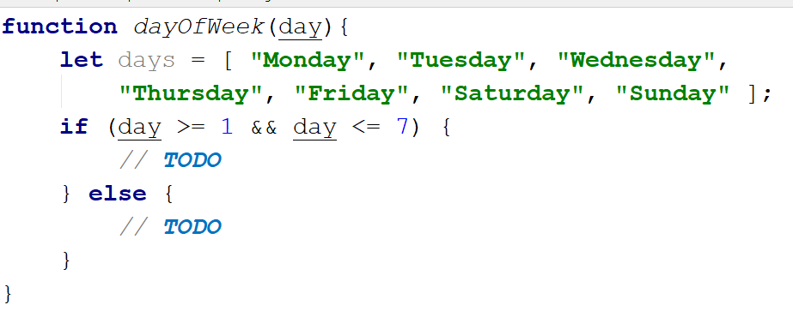

## Reverse an Array of Numbers

Receive a number **n** and an **array** of elements, **create** a **new** array with **n** numbers, **reverse** it and print its elements on a single line, space-separated.

### Examples

|  |  |
| --- | --- |
| **Input** | **Output** |
| 3, [10, 20, 30, 40, 50] | 30 20 10 |
| 4, [-1, 20, 99, 5] | 5 99 20 -1 |
| 2, [66, 43, 75, 89, 47] | 43 66 |

### Hints

Use **push** to add elements inside the new array.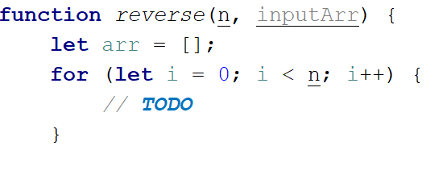

Use **string interpolation** for the output.

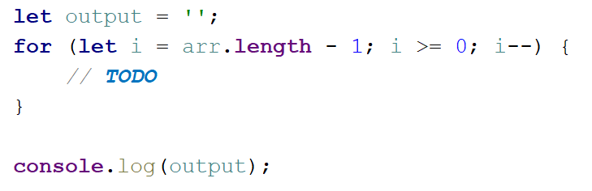

## Reverse an Array of Strings

Receive an **array of strings** (space separated values), reverse it and print its elements. **Swap** elements. For example the **first element should be last** and the **last element should be first** etc.

### Examples

|  |  |
| --- | --- |
| **Input** | **Output** |
| ['a', 'b', 'c', 'd', 'e'] | e d c b a |
| ['abc', 'def', 'hig', 'klm', 'nop'] | nop klm hig def abc |
| ['33', '123', '0', 'dd'] | dd 0 123 33 |

### Hints

Loop to the **half-length** of the array. Create a **function** to swap **two elements** inside an array.

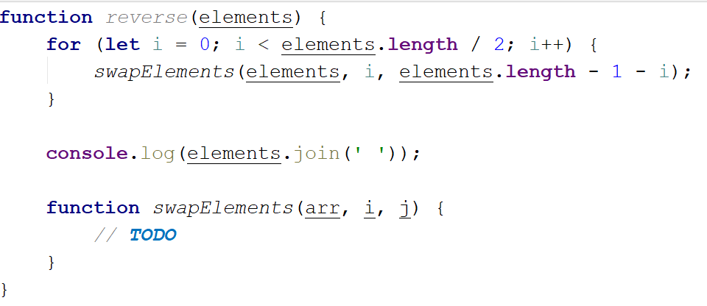

## Sum Even Numbers

Receive an **array of strings** parse them to **numbers** and sum only the **even** numbers.

### Examples

|  |  |
| --- | --- |
| **Input** | **Output** |
| ['1','2','3','4','5','6'] | 12 |
| ['3','5','7','9'] | 0 |
| ['2','4','6','8','10'] | 30 |

### Hints

First, we receive the **array of strings** and parse to numbers

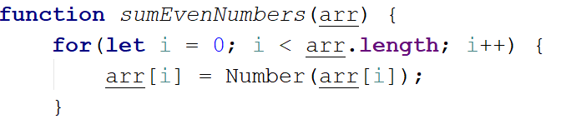

We will need a variable for the sum.

wH1zbzT

Iterate through all elements in the array with **for-of** loop.

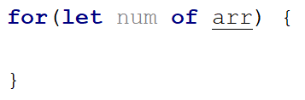

Check if the number is even.

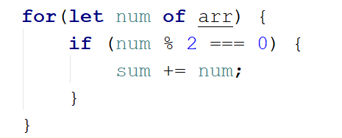

Print the total sum

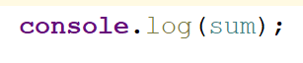

## Even and Odd Subtraction

Write a program that calculates the difference between the sum of the even and the sum of the odd numbers in an array.

### Examples

|  |  |  |
| --- | --- | --- |
| **Input** | **Output** | **Comments** |
| [1,2,3,4,5,6] | 3 | 2 + 4 + 6 = 12  1 + 3 + 5 = 9  12 – 9 = 3 |
| [3,5,7,9] | -24 |  |
| [2,4,6,8,10] | 30 |  |

### Hints

First, we receive the **array of strings** and parse to numbers



We will need two variables – **even** and **odd** sum.

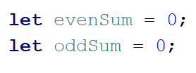

Iterate through all elements in the array with for-of loop and check if the number is odd or even.

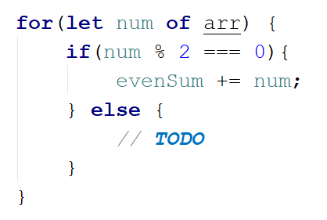

Print the difference.

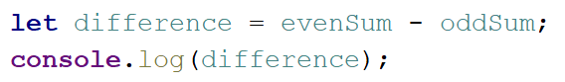

## Equal Arrays

Receive **two** **string arrays** and print on the console whether they are **identical** or not. Arrays are identical if their elements are **equal**. If the arrays are identical find the **sum** of the first one and print on the console following message: '**Arrays are identical. Sum: {sum}**', otherwise find the **first index** where the arrays **differ** and print on the console following message: '**Arrays are not identical. Found difference at {index} index**'.

### Examples

|  |  |
| --- | --- |
| **Input** | **Output** |
| ['10','20','30'], ['10','20','30'] | Arrays are identical. Sum: 60 |
| ['1','2','3','4','5'], ['1','2','4','4','5'] | Arrays are not identical. Found difference at 2 index |
| ['1'], ['10'] | Arrays are not identical. Found difference at 0 index |

### Hints

First we receive two string arrays and parse them.

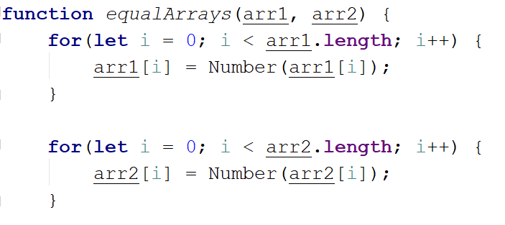

Iterate through arrays and compare element. If the elements are not equal print the required message and break the loop.

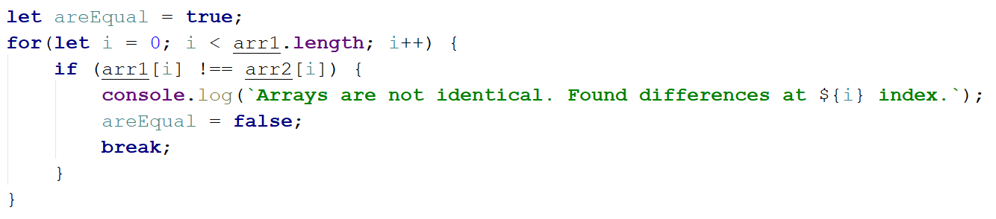

Think about how to solve the other part of the problem.

## Condense Array to Number

Write a program to receive **an array of numbers** and **condense** them by **summing** adjacent couples of elements until a **single number** is obtained. For example, if we have 3 elements {2, 10, 3}, we sum the first two and the second two elements and obtain {2+10, 10+3} = {12, 13}, then we sum again all adjacent elements and obtain {12+13} = {25}.

### Examples

|  |  |  |
| --- | --- | --- |
| **Input** | **Output** | **Comments** |
| [2,10,3] | 25 | 2 10 3 🡪 2+10 10+3 🡪 12 13 🡪 12 + 13 🡪 25 |
| [5,0,4,1,2] | 35 | 5 0 4 1 2 🡪 5+0 0+4 4+1 1+2 🡪 5 4 5 3 🡪 5+4 4+5 5+3 🡪 9 9 8 🡪 9+9 9+8 🡪 18 17 🡪 18+17 🡪 35 |
| [1] | 1 | 1 is already condensed to number |

### Hints

While we have more than one element in the array nums[], repeat the following:

* Allocate a new array condensed[] of size nums.Length-1.
* Sum the numbers from nums[] to condensed[]:
  + condensed[i] = nums[i] + nums[i+1]
* nums[] = condensed[]

The process is illustrated below:

